

**Faculty of engineering - Shoubra**

**Benha University**

**Research Article / Research Project / Literature Review**

in fulfillment of the requirements of

|  |  |
| --- | --- |
| **Department** | **Computer engineering** |
| **Division** | **-----------------** |
| **Academic Year** | **2019-2020 Preparatory** |
| **Course name** | **Computer engineering** |
| **Course code** | **ECE001** |

**Title: -**

**Artificial intelligence**

By:

|  |  |  |  |
| --- | --- | --- | --- |
|  | Name | Edu mail | B.N |
| 1 | عبدالرحمن محمد محمد محمد السيد غالي | [abdelrahman195522@feng.bu.edu.eg](mailto:abdelrahman195522@feng.bu.edu.eg) | 466 |

**Approved by:**

|  |  |
| --- | --- |
| Examiners committee | Signature |
| Dr. Ahmed Bayoumi |  |
| Dr. shady Elmshad |  |
| Dr.Abdelhamid Attaby |  |

Application brief :

Artificial intelligence "AI" : is a branch of computer science concerned with building smart machines to perform tasks that typically require human intelligence , also it interdisciplinary with multiple approaches , and it falls under broad categories { Narrow AI, Artificial General Intelligence "AGI"}.

* Narrow AI "Weak AI " : it operates within a limited context and simulation of human intelligence, and it's also focused on performing a single task extremely well, example : Google search, self-driving cars.
* Artificial General Intelligence "AGI" { strong AI } : it's consists of a machine with general intelligence like human being , and can be apply to solve any problem .

Types of AI

1. Reactive machines: this type of intelligence involves computer to perceiving the world directly and acting on what it sees , also we should build machines like this because human isn't very good at programming accurate simulated worlds.
2. Limited memory: this type of machines can look into the past, for example self driving cars they observe other cars' speed and direction that can't be done in one moment, and it also requires indentifying specific objects and monitoring them.
3. Theory of mind: understanding the people, creatures and objects in the world also this type has a relation with the machines that will be built in the future.
4. Self awareness: this will occur according to making decisions that depend on past experience.

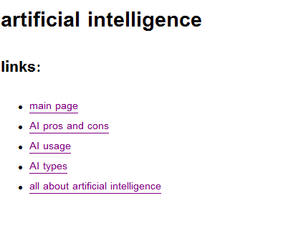Screen shots :

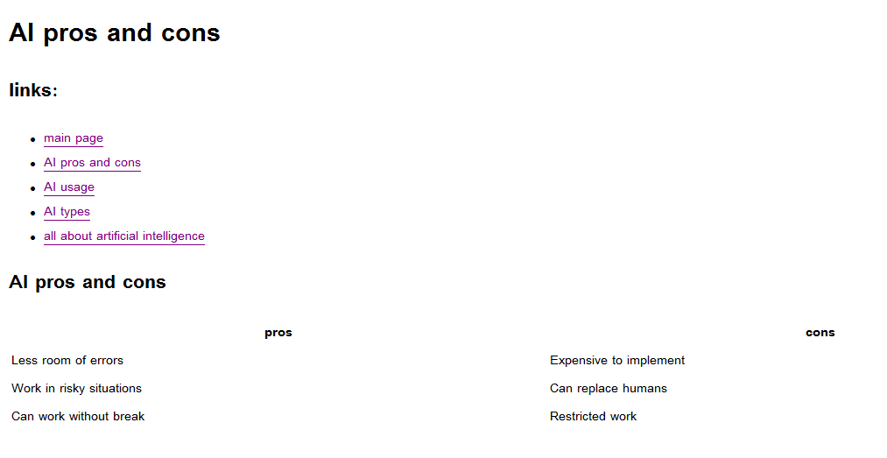

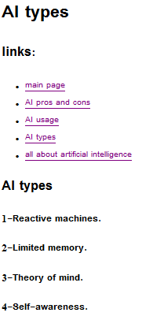

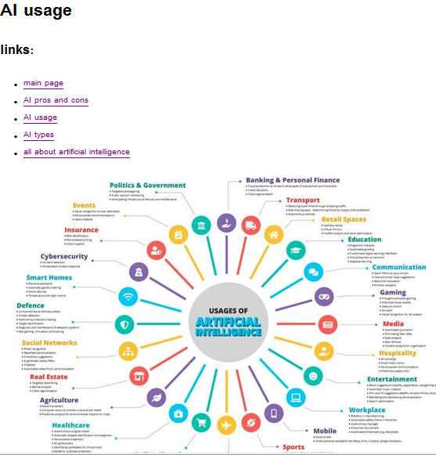

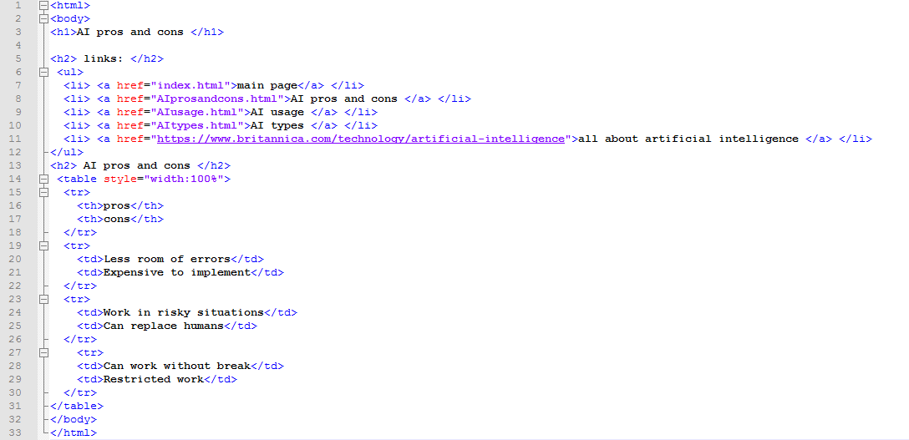Source code